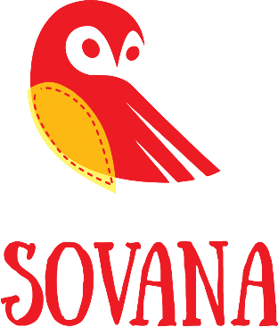

PRESS RELEASE

The heart and soul of the brand is the designer Anna Sovana from Krasnodar.
SOVANA is mainly conceived for teenagers and children. It may be a rather new brand but the looks created by Sovana have won the heart of many young fashionistas in quite a short time.
All sizes are made in small quantities, while some items are even unique, one-off pieces.
Regarding the fabrics to use, the choice falls on natural fabrics of the highest quality.
The dynamic and versatile "Fashion must to go" collection aims to convey the idea that fashion, regardless of restrictions and circumstances, will continue to thrive nevertheless.

